**Troubleshooting**

**Prerequisite:** Kiosk and smartphone must be connected to the same network.

How to check if SMS Service is running:

1. Open AMS
2. In the smart phone, open any browser.
3. Type http://<IP_ADDRESS>:54000/SMSService/Test  
   **Note:** Replace the <*IP_ADDRESS*> with the kiosk IP address
4. This screen should appear.  
   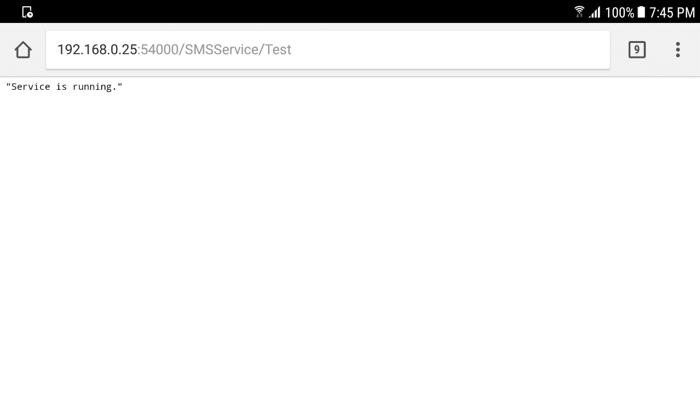

How to check if SMSGateway is running:

1. Open SMSGateway app.
2. Tap start.
3. The SMSGateway IP address should appear.  
   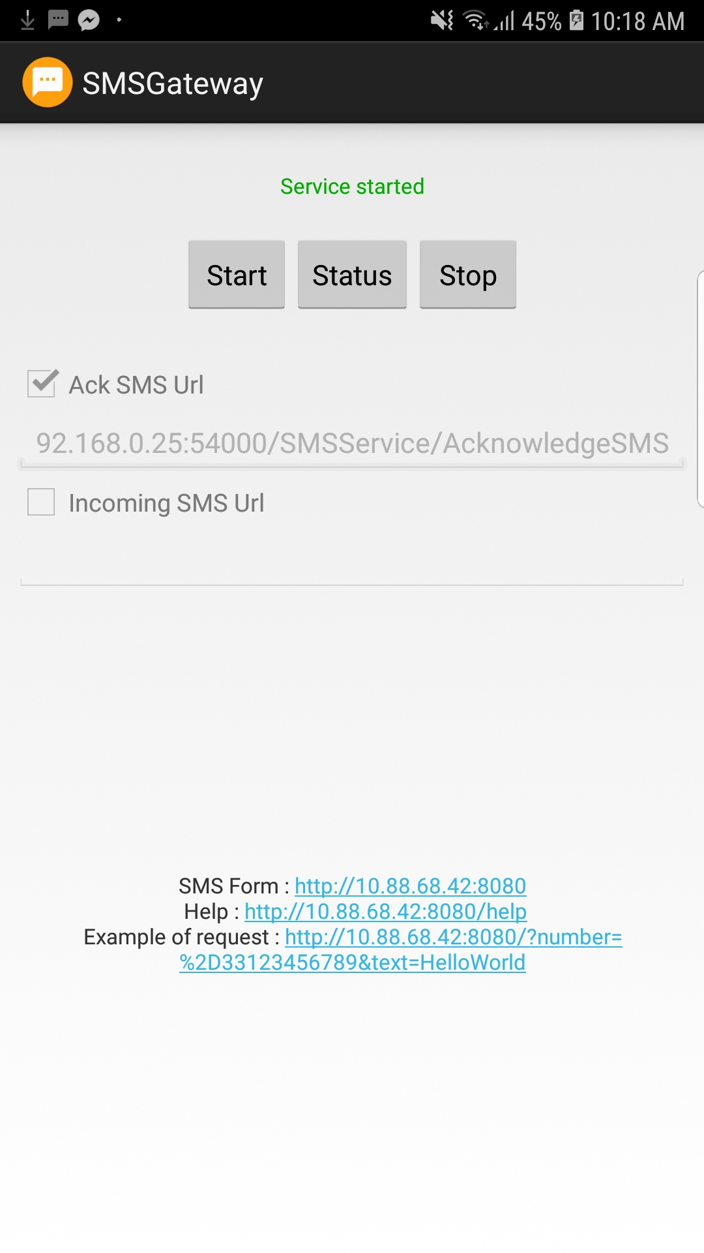
4. In the kiosk, open any browser.
5. Enter the SMS Form URL.
6. This page should appear.  
   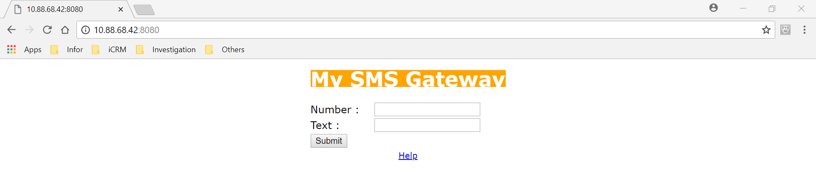

Note: In case that the kiosk cannot connect to the SMS Gateway, try restarting the SMS Gateway service.

Verifying correct IP addresses:

* After checking that both services are running, verify if the IP addresses are correct.

1. In the AMS program, go to Settings -> Configuration.  
   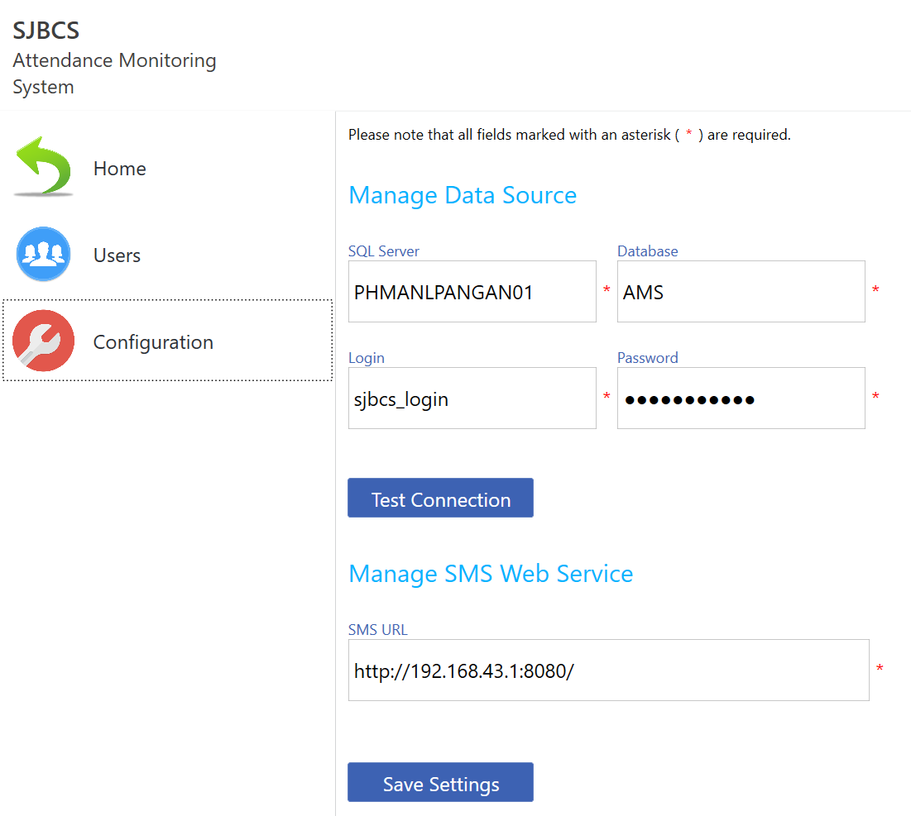
2. Check if the SMS URL is correct. It must be the same as the SMS Form URL.
3. In the SMS Gateway app, Ack SMS Url must be the IP address of the kiosk.  
   **URL:** http://<IP_ADDRESS>:54000/SMSService/AcknowledgeSMS  
   **Note:** Replace the <*IP_ADDRESS*> with the kiosk IP address  
     
   If not correct, stop first the SMS Gateway service then edit the URL. Start the service again.